10/06/2025

Qusai Mohammad, Varun Sanjay, shah zain, Ameer Hamza and Aisha

Care Group

Care Group Project

E-Project



**Project Documentation: CARE Group Web Application**

**Project Overview**

**Problem Statement**

Access to medical services is often hindered by long queues and manual appointment systems. CARE Group, a reputable name in healthcare services, identified this challenge and initiated the development of a comprehensive web-based platform to streamline medical access for patients across various cities.

**Objective**

To develop a responsive and user-friendly web application that enables users to search for doctors, schedule appointments online, access medical reports, and interact with an AI assistant—thereby reducing the need for in-person visits and enhancing accessibility to healthcare services.

**Key Features Summary**

* **Doctor Search Functionality**
* **Online Appointment Booking**
* **Role-Based Dashboards for Users, Doctors, and Administrators**
* **Medical Reports Management**
* **AI-Powered Medical Chatbot**
* **Secure Authentication using Jetstream**
* **Dynamic Blog with Filtering Options**
* **Email-Based Contact Form**

**Frontend Features**

**Navigation**

* Clean and intuitive navigation bar including: Home, About, Doctors, Departments, Blog, and Contact.
* Fully responsive and visually consistent UI/UX across devices.



**Doctor Search**

* Accessible via the “Find Doctor” button on the Home and About pages.
* Search by City, District, or Specialization.
* Redirects to a results page featuring an animated slider layout.

|  |  |
| --- | --- |
|  |  |
|  |  |
|  |  |

**Appointment Booking**

* User inputs: Name, Phone Number, Date, Doctor, and Message.
* Real-time availability check for selected dates.
* Dynamic list of available doctors.

|  |  |  |  |
| --- | --- | --- | --- |
|  |  |  |  |

**Authentication System**

* User-friendly login and registration interface with sliding animation.
* Secure authentication powered by Jetstream.
* Role-based redirection:
  + 0 = User
  + User Email:  
    [user@gmail.com](mailto:user@gmail.com)  
    password: Wellcom3
  + 1 = Admin

[admin@gmail.com](mailto:admin@gmail.com)

password: Wellcom3

* + 2 = Doctor

[qusai@aptechgdn.net](mailto:qusai@aptechgdn.net)

password: Wellcom3

**Contact Form**

* Submissions trigger an email notification to the Admin, containing the user's feedback.

|  |  |  |
| --- | --- | --- |
|  |  |  |

**Blog Page**

* Features dynamic content updates.
* Tag-based and keyword-based filtering system for various health categories such as cardiology and dermatology.

|  |  |
| --- | --- |
|  |  |

**Backend Features**

**User Dashboard**

* Accessible post-login via the navigation bar.
* Personalized greeting with categorized sections:
  + Upcoming Appointments
  + Past Appointments
  + 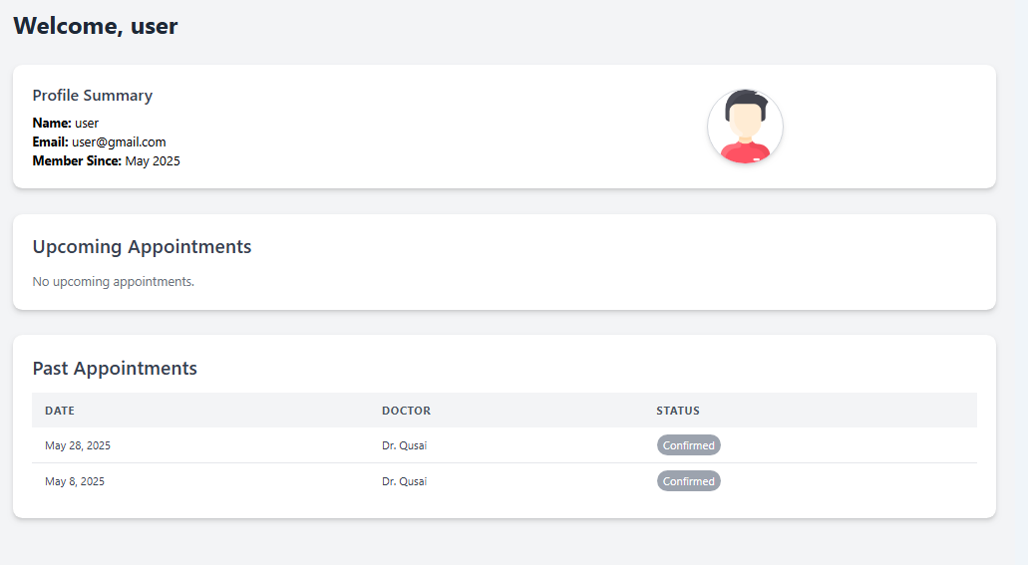Details include: Date, Doctor, and Status

**Appointment Management**

* + View, modify, or delete existing appointments.
  + Add new appointments with real-time doctor availability.

|  |  |
| --- | --- |
|  |  |

**Medical Reports**

* + Access and download reports including:
    - Current Medications
    - Illness History
    - Laboratory Reports

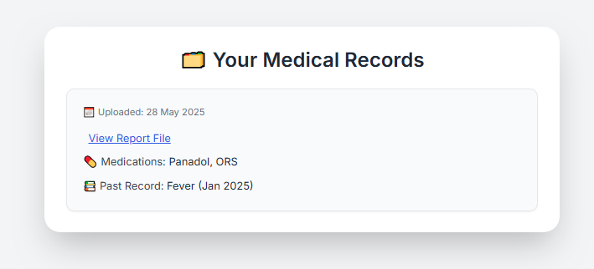

**AI Chatbot Integration**

* + Provides responses to symptom-related queries and general health questions.
  + Suggests appropriate treatments and specialists.
  + 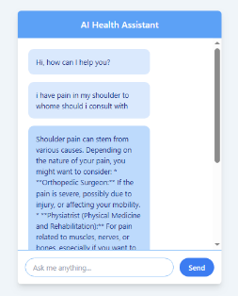Answers frequently asked questions regarding CARE Group services.

**Profile Management**

* + Edit personal details via profile image on the sidebar navigation.

**Admin Dashboard**

* Accessible upon login with a direct link to return to the public site.
* Dashboard overview includes:
  + Financial Statistics (Bar Charts)
  + Top Performing Doctors
  + Yearly Revenue Insights
  + All Appointments Overview
* **Doctor Management**
  + Add, search, edit, or remove doctors using filters (City, Name, District).
  + 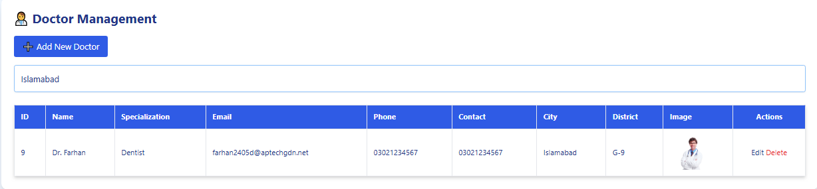Changes are reflected in real-time on the frontend.
* **Appointment Management**
  + Update or delete appointments.
  + Changes synchronize with user dashboards.

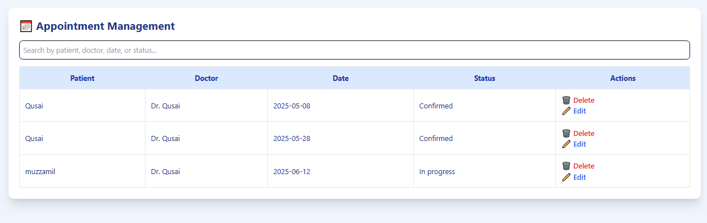

* **Reports and Medications**
  + Upload and manage:
    - Patient Reports
    - Prescription Details
    - Medical History

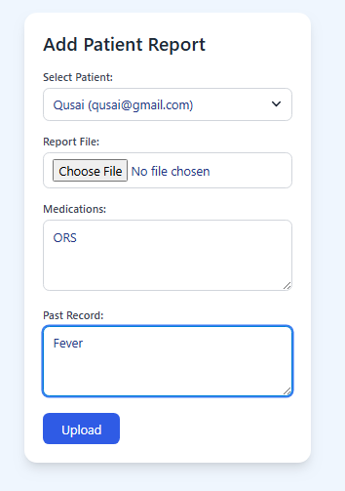

* **AI Chatbot for Admin**
  + Offers insights on financial growth, operational suggestions, and performance analytics.

**Doctor Dashboard**

* Direct login via assigned credentials.
* 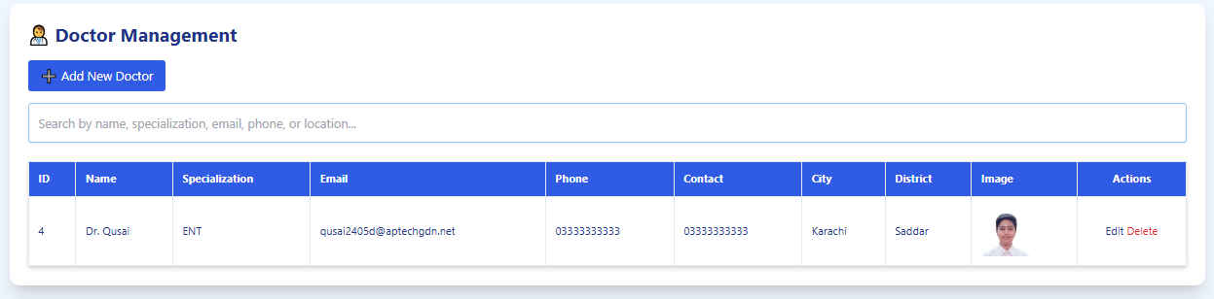"Doctor Dashboard" accessible from the public website.
* **Patient Appointment Management**
  + Doctors manage appointments assigned specifically to them.
  + Can update status, reschedule, or delete entries.
* **Report Management**
  + Add and edit patient reports and prescriptions.
  + Access limited to assigned patient records.
* **Profile Management**
  + Update doctor profile information with real-time reflection on the frontend.
* **Chatbot for Doctors**
  + Access medical references, drug information, and general assistance.

**Conclusion**

The CARE Group Web Application serves as a comprehensive full-stack healthcare platform, bridging the gap between patients and medical professionals. By integrating advanced appointment scheduling, intuitive dashboards, and AI-driven support, the system improves both patient experience and administrative efficiency.